CHAPTER-1
INTRODUCTION
In an era where security is paramount, the demand for efficient and cost-effective surveillance systems has significantly increased. Traditional security systems, while effective, often come with high costs and complex installations. This project addresses these challenges by presenting a DIY (Do It Yourself) security camera system that leverages widely accessible technology to create an affordable and easy-to-implement home surveillance solution.
The DIY security camera project utilizes Python, a versatile programming language, along with the OpenCV library for computer vision tasks and the winsound library for audio alerts. The primary objective of this project is to detect motion in real-time and alert the user through an audible alarm. By continuously monitoring the video feed from a webcam, the system identifies significant movement and provides immediate feedback, thus enhancing home security.
The system operates by capturing frames from a webcam, processing these frames to detect differences that indicate motion, and triggering an alarm when such motion is detected. The process begins with the acquisition of two consecutive frames from the webcam. These frames are then processed to compute the absolute difference, which highlights the areas of change. The resultant image is converted to grayscale and subjected to a binary threshold to enhance the contours of moving objects. The contours are analyzed, and if any contour exceeds a predefined area threshold, an alarm sound is generated using the winsound library.
The simplicity and effectiveness of this approach make it an ideal solution for individuals seeking to enhance their home security without investing in expensive commercial systems. Additionally, the project serves as an excellent learning opportunity for those interested in exploring computer vision and real-time image processing using Python.
This report details the system's design, implementation, and testing results, providing a comprehensive guide for anyone looking to build their own security camera system. By leveraging open-source libraries and basic hardware, this project demonstrates the potential of DIY solutions in addressing everyday security needs.
CHAPTER 2
ABOUT
Jupyter notebook
Jupyter Notebook is an open-source web application that provides an interactive environment for creating and sharing documents that contain live code, equations, visualizations, and narrative text. Originally designed for Python, it now supports over 40 programming languages, including R, Julia, and Scala, through the use of different kernels. Jupyter Notebook is widely used in data science, scientific computing, and machine learning due to its ability to combine code execution with rich text elements. It supports data visualization libraries like Matplotlib, Seaborn, and Plotly, allowing users to create and display complex visualizations directly within the notebook. Additionally, users can include various forms of media, such as images and videos, making it an excellent tool for creating educational materials and detailed reports. The notebook's interactive coding environment enables real-time experimentation with code and immediate viewing of results, which is especially useful for data analysis, model development, and testing. Furthermore, Jupyter Notebooks facilitate collaboration by allowing easy sharing as static files or interactive documents hosted on platforms like JupyterHub or Google Colab. This feature-rich environment, combining code, text, and media, fosters an interactive and collaborative approach to programming and data analysis, making it a powerful tool for educational, research, and professional applications.
Key Components
- Cells: The primary building blocks of a Jupyter Notebook. There are different types of cells, including code cells (for writing and executing code) and markdown cells (for writing formatted text).
- Kernel: The computational engine that executes the code contained in the notebook. Different kernels can be used to support various programming languages.

OpenCV
OpenCV (Open Source Computer Vision Library) is an open-source computer vision and machine learning software library. It contains more than 2500 optimized algorithms for a wide range of applications, including image processing, video capture and analysis, object detection, and more. OpenCV is designed to provide a common infrastructure for computer vision applications and to accelerate the use of machine perception in commercial products. Since its release, OpenCV has become one of the most popular and widely used libraries in the field of computer vision.
Features of OpenCV
1. Image Processing: OpenCV provides a vast array of functions to perform image processing tasks such as filtering, edge detection, color space conversion, and geometric transformations. These functions enable developers to manipulate and analyze images effectively.
2. Video Capture and Analysis: OpenCV supports real-time video capture and processing. It can interface with various video input sources such as webcams, video files, and network streams, making it ideal for applications like surveillance and motion detection.
3. Object Detection: OpenCV includes pre-trained models and functions for detecting objects in images and videos. This includes face detection, pedestrian detection, and object tracking, which are essential for building advanced computer vision applications.
4.Machine Learning: OpenCV integrates with machine learning libraries and frameworks, providing tools for training and deploying machine learning models. It supports traditional algorithms like k-means clustering, as well as modern deep learning frameworks such as TensorFlow and PyTorch.

5. Cross-Platform Support: OpenCV is cross-platform and runs on Windows, Linux, macOS, iOS, and Android. This flexibility allows developers to deploy their applications across different environments.
6. Performance Optimization: OpenCV is optimized for real-time performance. It includes features like multi-threading, GPU acceleration, and SIMD (Single Instruction, Multiple Data) instructions to enhance the efficiency of computer vision tasks.

CHAPTER-3
SYSTEM DESIGN

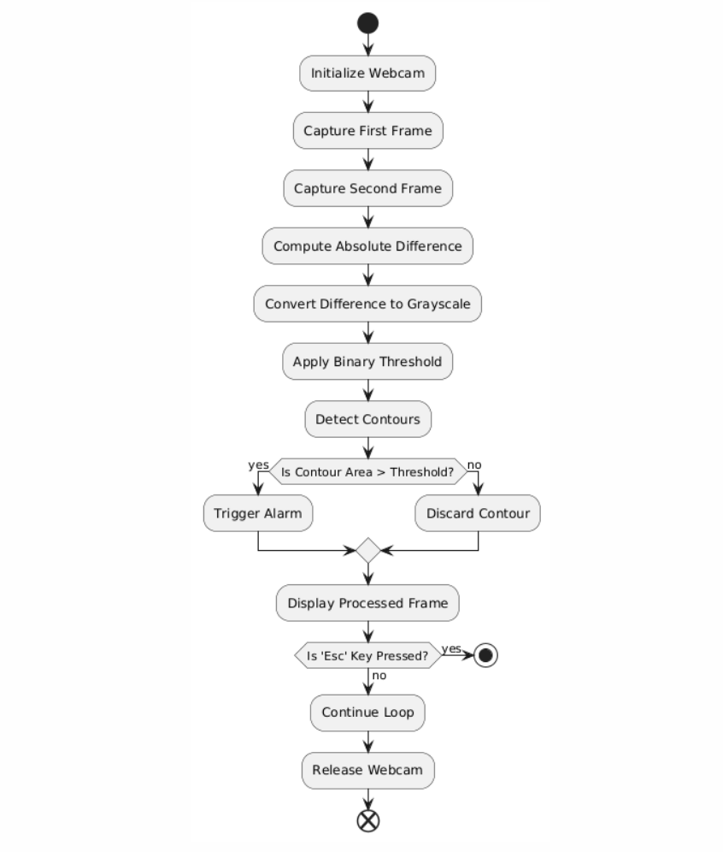
Fig 3.1 Flowchart
This flowchart outlines the steps involved in a motion detection system using a webcam. Here’s a detailed explanation of each step:
- Initialize Webcam: Start by initializing the webcam to begin capturing video frames.
- Capture First Frame: Capture the first frame from the webcam to use as a reference frame.
- Capture Second Frame: Capture the second frame from the webcam, which will be compared to the first frame to detect any motion.
- Compute Absolute Difference: Calculate the absolute difference between the first and second frames. This step highlights the areas where motion has occurred.
- Convert Difference to Grayscale: Convert the difference image to grayscale to simplify further processing. Grayscale images have only one channel, which makes them easier to process than color images.
- Apply Binary Threshold: Apply a binary threshold to the grayscale difference image. This step converts the grayscale image to a binary image, where pixels are either black or white. This helps in clearly distinguishing areas of motion.
- Detect Contours: Detect the contours in the binary image. Contours are the outlines or boundaries of the areas where motion is detected.
- Is Contour Area > Threshold?: Check if the area of any detected contour is greater than a predefined threshold. This step helps in filtering out small, insignificant motions (like minor changes in lighting) and focusing on significant movements.
  - Yes: If the contour area is greater than the threshold, trigger an alarm indicating that significant motion has been detected.
  - No: If the contour area is not greater than the threshold, discard the contour.
- Display Processed Frame: Display the processed frame with the detected contours and any other relevant information. This step provides visual feedback to the user.
- Is 'Esc' Key Pressed?: Check if the 'Esc' key has been pressed. This step allows the user to exit the motion detection loop.
  - Yes: If the 'Esc' key is pressed, release the webcam and end the program.
  - No: If the 'Esc' key is not pressed, continue the loop and go back to capturing the next frame.
- Continue Loop: If the 'Esc' key has not been pressed, go back to capturing the next frame to continue monitoring for motion.
Trigger alarm
Convert to counter
Video capture
Web camera

Fig 3.2 Use Case Diagram
12. Release Webcam: Release the webcam resources and clean up any resources before ending the program.
This flowchart describes a typical motion detection system using image processing techniques. The steps are designed to detect and respond to significant movements captured by the webcam in real time.
System Design
Components
- Webcam Initialization: Initializes the webcam for capturing video frames.
- Frame Capture Loop: Continuously captures frames from the webcam.
- Frame Difference Calculation: Calculates the difference between consecutive frames to detect motion.
- Grayscale Conversion: Converts the difference image to grayscale for easier processing.
- Threshold Application: Applies a binary threshold to the grayscale image to highlight areas of motion.
- Contour Detection: Detects contours in the thresholded image to identify areas of significant motion.
- Motion Detection and Alert: Checks the size of detected contours and triggers an alert if the motion is significant.
- Display Frame: Displays the processed frame to the user.
- Exit Condition: Exits the loop and releases resources if the 'Esc' key is pressed.
Tools and Libraries
- OpenCV (cv2): This library is cross-platform and provides a wide range of functionalities for computer vision tasks. In this project, it is used for capturing video frames, performing image processing operations, and displaying the results.
- winsound: This module is specific to Windows and is used to play sound. It helps in generating a beep sound when significant motion is detected.

Workflow
- Initialize the webcam.
- Enter a continuous loop to capture frames.
- Calculate the absolute difference between consecutive frames.
- Convert the difference image to grayscale.
- Apply a binary threshold to the grayscale image.
- Detect contours in the thresholded image.
- Check if any contour area exceeds the threshold.
- If yes, trigger an alert.
- Display the processed frame.
- Check if the 'Esc' key is pressed.
- If yes, exit the loop.
- Release the webcam and close all OpenCV windows..

CHAPTER-4
SYSTEM IMPLEMENTATION
- Header files:
1. cv2
- Library: OpenCV
- Description: OpenCV (Open Source Computer Vision Library) is an open-source computer vision and machine learning software library. It includes hundreds of computer vision algorithms. It is widely used for image processing, video capture, and analysis.
2. winsound
The winsound module is a Windows-specific module that provides access to the basic sound-playing machinery provided by Windows. It is used to play simple sound notifications, which in this case is used to alert when significant motion is detected.
Here's an overview of the winsound functions used:

winsound.Beep(frequency, duration)
- frequency: The frequency of the beep sound, in Hertz. The frequency range is hardware-dependent but typically lies between 37 Hz and 32767 Hz.
- duration: The duration of the beep sound, in milliseconds.
3. OS
- Library: os (part of the Python Standard Library)
- Description: The os module provides a way of using operating system-dependent functionality like reading or writing to the file system. It is used for interacting with the operating system.

- Data types:
- cv2.VideoCapture: Used for capturing video from the webcam.
- bool: Represents the success of the frame capture.
- np.ndarray: Represents image frames, grayscale images, difference images, thresholded images, and contours.
- list of np.ndarray: Represents the list of contours detected.
- int: Used for key press detection and the area of contours.
- float: Used for the area of contours.
By understanding these data types, you can better grasp how the motion detection system processes and analyzes video frames to detect motion and trigger alerts.
- Functions:

1. cv2.VideoCapture()
- Usage: webcam = cv2.VideoCapture(0)
- Description: Initializes video capturing from the webcam. The argument 0 specifies the first camera device.

2. webcam.read()
- Usage: _, im1 = webcam.read()
- Description: Captures a frame from the video. Returns a boolean indicating if the frame was captured successfully, and the captured frame itself as a NumPy array.

3. cv2.absdiff()
- Usage: diff = cv2.absdiff(im1, im2)
- Description: Calculates the absolute difference between two arrays or images.

4. cv2.cvtColor()
- Usage: gray = cv2.cvtColor(diff, cv2.COLOR_BGR2GRAY)
- Description: Converts an image from one color space to another. Here, it converts the difference image from BGR (Blue, Green, Red) to grayscale.

5. cv2.threshold()
- Usage: _, thresh = cv2.threshold(gray, 20, 255, cv2.THRESH_BINARY)
- Description: Applies a fixed-level threshold to a grayscale image. Pixels with a value above the threshold (20) are set to the maximum value (255), and others are set to 0. This results in a binary image.

6. cv2.findContours()
- Usage: contours, _ = cv2.findContours(thresh, cv2.RETR_TREE, cv2.CHAIN_APPROX_SIMPLE)
- Description: Detects contours in a binary image. Returns a list of contours found. Each contour is a list of points.

7. cv2.contourArea()
- Usage: if cv2.contourArea(c) < 5000:
- Description: Calculates the area of a contour. This is used to filter out small contours.

8. winsound.Beep()
- Usage: winsound.Beep(500, 100)
- Description: Produces a beep sound. The first argument is the frequency in Hertz (500 Hz), and the second argument is the duration in milliseconds (100 ms).

9. cv2.imshow()
- Usage: cv2.imshow("security camera", gray)
- Description: Displays an image in a window. The first argument is the window name, and the second argument is the image to be displayed.

10. cv2.waitKey()
- Usage: if cv2.waitKey(10) == 27:
- Description: Waits for a key event for a specified amount of time (10 milliseconds here). Returns the ASCII value of the key pressed. 27 corresponds to the 'Esc' key.

11. webcam.release()
- Usage: webcam.release()
- Description: Releases the video capture object and frees the webcam resource.

12. cv2.destroyAllWindows()
- Usage: cv2.destroyAllWindows()
- Description: Closes all the windows opened by OpenCV.

CHAPTER-5
RESULTS
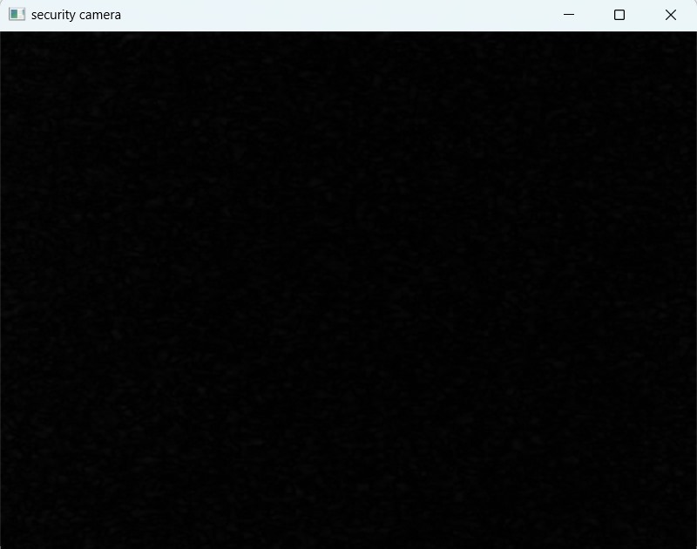
Fig. 5.1: web camera opened

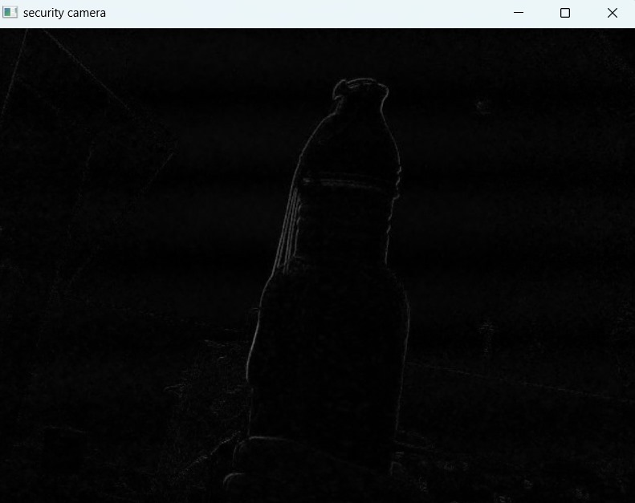
Fig. 5.2 : recognition of objects
CHAPTER-6
CONCLUSION
Creating a DIY security camera with image processing capabilities is a rewarding project that combines hardware and software to enhance security and surveillance. This project leverages affordable components such as the Raspberry Pi, cameras, and open-source libraries like OpenCV, making advanced security technology accessible to hobbyists and those with a limited budget.Remote monitoring capabilities are another significant advantage. By configuring network settings and using applications or web interfaces, users can access live feeds and recorded footage from anywhere in the world. This feature is particularly useful for frequent travelers or individuals who want to keep an eye on their property in real-time.
The project also provides an excellent learning opportunity. It encompasses various disciplines, including electronics, programming, and image processing. Assembling the hardware, configuring the software, and implementing image processing algorithms foster practical skills and a deeper understanding of how modern security systems operate. This knowledge can be invaluable for those pursuing careers in technology or those who enjoy hands-on technical projects.
A DIY security camera with image processing is a powerful and cost-effective solution for enhancing security and surveillance. It combines the affordability of DIY projects with the advanced features of modern security systems, offering personalized and flexible security solutions. The project not only provides practical benefits in terms of home security but also serves as an educational experience, promoting skills in electronics, programming, and image processing. While challenges exist, they can be mitigated with careful planning, regular maintenance, and a focus on privacy and legal compliance. Overall, this project demonstrates the potential of DIY technology to meet modern security needs effectively and affordably.

REFERENCE
- Raspberry Pi Official Website: Provides comprehensive documentation and resources for using Raspberry Pi in various projects, including security cameras.
- OpenCV Library: An open-source computer vision and machine learning software library that provides a range of tools for image processing.
- GitHub Repositories: Explore repositories that contain code and projects related to DIY security cameras using Raspberry Pi and OpenCV.
- PyImageSearch Blog: Offers tutorials and guides on image processing and computer vision using Python, including DIY security camera projects.
- Instructables: A community-driven platform with step-by-step guides for DIY projects, including security cameras using image processing.
- Hackster.io: A hardware-focused community where users share projects and tutorials on DIY electronics and programming, including security cameras.
- Element14 Community: Provides resources, project ideas, and discussions on DIY electronics, including tutorials for building security cameras.
- YouTube Tutorials: Video tutorials can be very helpful for visual learners. Channels like "The Raspberry Pi Guy" and "Core Electronics" offer detailed guides on DIY security cameras.
- Books on Raspberry Pi and OpenCV: Books such as "Learning OpenCV 4 Computer Vision with Python" by Joseph Howse and "Raspberry Pi Projects for the Evil Genius" by Donald Norris provide in-depth knowledge and project ideas.
- Forums and Online Communities: Engaging with forums such as Stack Overflow, Reddit, and the Raspberry Pi forums can provide support and additional resources from other enthusiasts and experts.

